## http://www.iceskate.org/images/school-out.jpgAlgebra 2 Trig G Name________________________________

Review For Semester 2

**Chapter 8 – RATIONAL EXPRESSIONS**

Simplify the fraction or rational expression:

1)  2) 

3)  4) 

5)  6) 

7)  8) 

9)  10) 

**Chapter 9 - LOGARITHMS**

Simplify.

11) Sketch a graph of the function. State its Domain and Range.





Domain:

Range:

Growth OR Decay?

12) Write the exponential function that passes through  and  *use your calculator*

Solve each equation.

13)  14) 

Write each equation in **logarithmic form**.

15)  16) 

Write each equation in **exponential form**.

17)  18) 

Solve each equation.

19)  20) 

21)  22) 

23)  24) 

25)  26) 

27)  28) 

Use  and  to evaluate the expression.

29)  30)  31)  32) 

**Change each log expression to common logs. (round answers to four decimal places)**

33)  34)  35)  36) 

**Solve each equation below. (round final answers to four decimal places)**

37)  38)  39) 

**Use the equation:  to answer #40 and 41 (round final answers to four decimal places)**

40) Tessa is saving for a new TV and stereo system. She just received $2000 for graduation and plans to invest it in an account that earns 4.35% interest compounded monthly. How long will she need to invest her money in order to have the $3000 she needs to buy the system?

41) Phil wants to double his $17000 investment in 8 years. What interest rate would he need if the interest is compounded 6 times per year?

**Use the equation  to solve #42 and 43. (round final answers to four decimal places)**

42) The population of Hinsdale was 2,800 people in the year 1910. By 1950, the population had increased to 12,500 people.

1. What was the rate of growth (b) per year for Hinsdale during that time?
2. If that growth rate continues, what will the population be in the year 2015?
3. When will the population reach 1 million people?

**Chapter 13 - TRIG**

43) Change  to radians 44) Change  to radians

45) Change  radians to degrees 46) Change  radians to degrees

47) Find the exact value of  48) Find the exact value of 

49) Find the exact value of  50) Find the exact value of 

51) Find the exact value of  52) Find the exact value of 

53) Find the exact value of  54) Find the exact value of 

55) Find  in degrees. 56) Find  in degrees.

**Chapter 14 – GRAPHING TRIG FUNCTIONS**

57) Graph the function.

 Amplitude: ________ Period:__________ Critical Values: __________

Vertical Shift: _______ Max: _______ Min: _______ Horizontal Shift: ________

58) Graph the function.

 Amplitude: ________ Period:__________ Critical Values: __________

Vertical Shift: _______ Max: _______ Min: _______ Horizontal Shift: ________

59) Graph the function.

 Amplitude: ________ Period:_________ Critical Values: __________

Vertical Shift: _______ Max: _______ Min: _______ Horizontal Shift: ________

**Chapter 12 - PROBABILITY**

Answer the following questions about counting and probability.

60) How many ways can you form an outfit of shoes, pants, and a shirt if there are 10 pairs of shoes to choose from, 5 pairs of pants, and 5 shirts?

61) How many ways can you arrange 8 books on a shelf?

62) A die is rolled twice. What is the probability of:

* + 1. Getting an odd and then an even
    2. Getting a 5 both times

c) Getting a number less than 3 both times

63) A coin is tossed 3 times. Find the probability of getting 2 tails and 1 heads, in any order (make a tree diagram☺)

64) In my wallet there are 4 ten dollar bills and 6 five dollar bills. If three bills are drawn at random with no replacement, find the probability of the following:

a) P(2 tens and then a five) b) P(3 fives)

65) How many different 7-digit phone numbers can be formed if the first three digits can be any number and the last four digits cannot be 0 or 1?

66) How many 8-character passwords can be formed if the first 4 characters are non-repeating letters and the last 4 characters are numbers?

67) What is the probability of drawing, without replacement, 2 clubs, and then a diamond from a standard deck of cards?

68) What is the probability of drawing, without replacement, an Ace, then a 7, and then another Ace from a standard deck of cards?

69) Bobby has a standard deck of playing cards. He picks one card out of the deck. What is the probability that it is a 9 or a black card?

70) Frank has a standard deck of playing cards. He picks one card out of the deck. What is the probability that it is a King or a spade?

**STATISTICS**

71) The data set below gives the numbers of touchdowns for the 8 quarterbacks who threw the most touchdowns during a regular NFL season. Find the standard deviation.

55, 50, 49, 48, 46, 45, 44, 43

72) Describe the distribution based on the shape of the histogram. You may choose more than one term.

(Uniform, Symmetric, Skewed Left, Skewed Right, No Mode, Unimodal, Bimodal, Multimodal)

[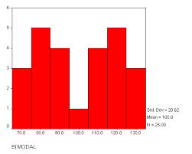](http://www.google.com/url?sa=i&rct=j&q=&esrc=s&source=images&cd=&cad=rja&uact=8&ved=0CAcQjRw&url=http://www.chemicalpics.com/right-skewed-distribution-graph/&ei=K11TVafTIsmdsAX2i4HQCg&bvm=bv.93112503,d.b2w&psig=AFQjCNHKwYskgb39ixYeu6Scbsyt8DGPig&ust=1431612995963678)

[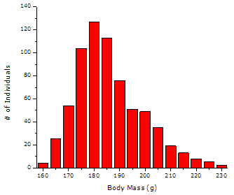](http://www.google.com/url?sa=i&rct=j&q=&esrc=s&source=images&cd=&cad=rja&uact=8&ved=0CAcQjRw&url=http://www.connectseward.org/shs/da1/review07/Describing%20a%20Distribution.htm&ei=fFtTVdfTJYPxsAWTuoH4Bg&bvm=bv.93112503,d.b2w&psig=AFQjCNHC3fB_0ZU5rAUL9SsdHMhFSQPLEQ&ust=1431612663273009)[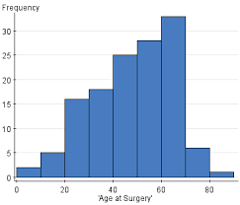](http://www.google.com/imgres?imgurl=http://www.statcrunch.com/grabimageforreport.php?reportid%3D11460%26image_id%3D448291&imgrefurl=http://www.statcrunch.com/5.0/viewreport.php?reportid%3D11460&h=315&w=368&tbnid=IMsl5wLraBVu0M:&zoom=1&docid=kKfaE1G4ChgQFM&ei=zlxTVYziI8j7sAWEu4CwAQ&tbm=isch&ved=0CF8QMyhXMFc4ZA)a. b. c.

73) Find the following probabilities based on the normal distribution.

a. P( x < µ + ) b. P( µ – 3 < x < µ + 3)

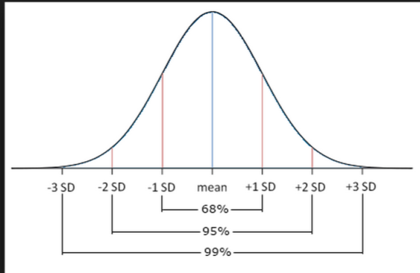

μ-3σ μ-2σ μ-σ μ μ+σ μ+2σ μ+3σ

c. P( x > µ – ) d. P( µ – 2< x < µ + )

74) Hourly wage at a company is *normally distributed*.  The mean hourly wage is $10.75 and the standard deviation is $2.25.

a) What percent of people have an hourly wage that is less than $7.85?

b) What percent of people have an hourly wage that is greater than $15.35?

**ARITHMETIC AND GEOMETRIC SEQUENCES**

75) Is the sequence arithmetic or geometric?

a) 2, 6, 18, 54, 162, … b) -8, -3, 2, 7, 12, …

76) An arithmetic sequence begins with the terms 5, 27, 49, 71, … One of the terms in the sequence is 1391. Find the term number.

77) An arithmetic sequence begins with the term -6 and the 18th term is -193. Find the common difference (d).

78) A geometric sequence begins with the terms 1000, 500, 250, 125, … Find the 8th term.

79) A geometric sequence begins with the term 2 and the 13th term is 8192. Find the common ratio (r).