Name_______________________________________________ Date_________________ Hour____________

**REVIEW 9.1 – 9.3**

*Algebra 2 Trig G*

**1. Sketch the graph. State the function’s domain and range, and circle whether it is decay or growth.**

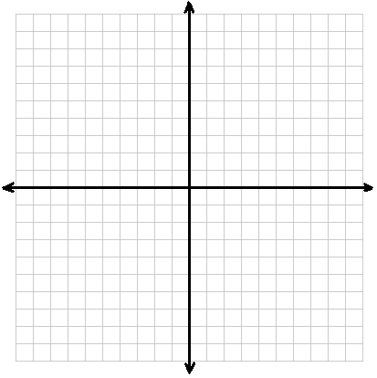



Domain: _____________________

X Y Range: _____________________

-1

0 Decay / Growth ?

1

2

3

**2 – 3. Determine whether each function represents exponential GROWTH or DECAY.**

**2.  3. **

______________ ______________

**4.** **Using a calculator, write the equation of an *exponential function* that passes through the given points.**



**5 – 6. Solve each equation.**

**5.  6. **

7. **Write the equation in exponential form. 8. Write the equation in logarithmic form.**

 

_______________ _______________

**9 – 10. Rewrite each statement using only **

**9.  10. **

**11 – 12. Use  ,  , and  to approximate the value of:**

**11.  12. **

**13 – 16. Switch to exponential form and solve for x.**

**13.  14. **

**15.  16. **

**17 – 22. Combine to get a single log on each side and solve for x.**

**17.  18. **

**19.  20. **

**21.  22. **