Algebra 2 Trig Assignments

Chapter 8
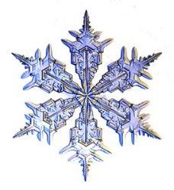

1/9 | 1/10  Section 8.1  p.446  #1 – 15 odd | 1/11  Section 8.1  Worksheet | 1/12  Section 8.2  p.453  #1 – 11 odd | 1/13  8.1  QUIZ
1/16  NO  SCHOOL! | 1/17  Section 8.2  p.453-454  #8 – 12 even,  25 – 29 odd | 1/18  Section 8.6  p.484  #1, 2, 5, 10 – 15,  22 – 23 | 1/19  Section 8.6  p.484-486  #3, 4, 6, 16, 43  p.488  #1 – 4 | 1/20  Chapter 8 Review  Review  Worksheet
1/23  Late Start  Chapter 8 Review  Study | 1/24  CHAPTER 8  QUEST | 1/25 | 1/26 | 1/27

