Algebra 2 Trig G Assignments

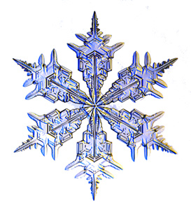
Chapter 8

1/8 | 1/9  Review Simplifying Fractions  Worksheet | 1/10  Section 8.1  8.1 Skills Practice | 1/11  Section 8.1  8.1 Practice | 1/12  Section 8.2  8.2 Skills Practice
1/15  NO  SCHOOL! | 1/16  Section 8.2  8.2 Practice | 1/17  Section 8.1 – 8.2  Review  Worksheet | 1/18  Review  Study! | 1/19  QUIZ  8.1-8.2

