Chapter 6 – Algebra 2 Trig G
11/14  Late Start  Section 6.1  6.1 Skills Practice | 11/15  Section 6.1  6.1 Worksheet | 11/16  Section 6.2  6.2 Skills Practice | 11/17  Section 6.2  6.2  Worksheet | 11/18  Review  6.1-6.2  Worksheet
11/21  NO Late Start  Review  6.1-6.2  Study! | 11/22  QUIZ  6.1-6.2 | 11/23  11:30 dismissal  FUN  DAY | 11/24  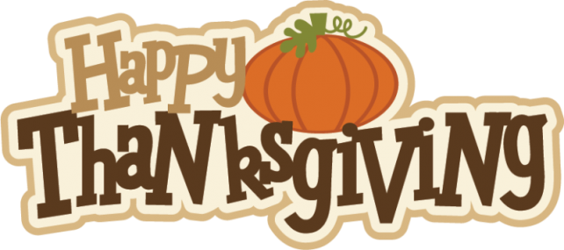 | 11/25
11/28  Late Start  “Find Someone Who”  &  Go over quiz | 11/29  Teachers will be absent  Facing Math worksheet | 11/30  Section 6.3  6.3 Study Guide Worksheet | 12/1  Section 6.3  6.3 Skills Practice | 12/2  Review  6.1-6.3  Worksheet
12/5  Late Start  Review  6.1-6.3 | 12/6  Review  6.1-6.3 | 12/7  QUIZ  6.1-6.3 | 12/8  HW Make-up  Day! | 12/9  FUN  DAY
12/12  Late Start  EXAM  REVIEW | 12/13  Holiday Concert  EXAM  REVIEW | 12/14  EXAM  REVIEW | 12/15  EXAM  REVIEW | 12/16  EXAM  REVIEW
12/19  FINAL  EXAMS | 12/20  FINAL  EXAMS | 12/21  FINAL  EXAMS

